Report title |  |  | Engagement & Staff Survey
Report from |  |  | Anne Robson, Interim Director of Workforce and OD
Prepared by |  |  | Carolyn Parker, Organisational Development Consultant
Link to strategic objectives |  |  | Supporting all our people to realise their potential and be heard and valued
Executive summary:

We have agreed to focus on three themes for our Trust wide Staff Survey action plan. They are as follows:

- We are always learning – at 5.5 out of 10, this remains our lowest scoring NHS People Promise theme.
- We are recognised and rewarded – at 5.7 out of 10, this remains our second lowest scoring NHS People Promise theme.
- We are safe and healthy – at 6.1 out of 10, this was the only NHS People Promise theme to deteriorate year-on-year.

The first two themes are a continuing focus area, having featured on the trust wide action plan in 2021. Whilst the We are safe and healthy theme is a new focus area in response to 2022 results, it does contain questions relating to Bullying, Harassment and Abuse, which was a focus area in 2021 and continues to be so this year.

Colleague engagement:

Appendix A contains the draft action plan, which includes both new and continuing actions. We have undertaken three colleague engagement sessions to share the Staff Survey results more widely and to socialise the action plan. In doing so, we have asked colleagues to share their feedback regarding the results, the proposed actions, and any additional ideas that they have to ensure we deliver impactful change. The sessions have been opened and led by a member of the executive, to underscore the importance that our senior leadership place on the Staff Survey and responding to it. In total, three sessions have been undertaken on Friday 12 May, Thursday 18 May and Wednesday 24 May. Owing to the timing of these sessions, a verbal update is provided to the Board regarding the insights and themes that have emerged.

Developing and delivering meaningful action:

The action plan will be reviewed in light of the feedback from our colleague engagement sessions. In addition, work is underway to speak with the Senior Responsible Officers (SRO) for each of the Excellence portfolio’s programme boards to ensure that the action plan accurately reflects all of the work that is underway to improve our Staff Survey results against the identified themes, whilst maintaining integrity that we include only those actions being taken as a direct result of the Staff Survey.

In addition to the trust wide action plan, each Directorate is also producing a local action plan. This may mirror the themes identified at a trust level or differ according to local results. Where appropriate, the local action plan will align to the trust wide action plan, noting how it intends to draw upon and/or embed trust wide initiatives, for example Active Bystander. The deadline for all action plans is 31 May, with Divisional action plans being governed via the monthly Performance meetings. In addition, the senior leadership of the Divisions will be invited to present their action plans and progress at the People and Culture Committee in September 2023.

Other considerations:

In addition to the Staff Survey action plan, there are other projects that are underway which are intended to have a positive impact on our colleagues’ experience, and therefore may impact on Staff Survey scores. These include:

- Leadership Academy Programme – a programme for colleagues who have a disability or long-term health condition, being delivered in collaboration with Disability Rights UK. Aimed at addressing perceptions re: progression and development.
- Career Sponsorship Programme – a programme for Black, Asian and Minority Ethnic colleagues. Aimed at addressing perceptions re: progression and development.
- Values work – a programme of work to bring our values of Excellence, Equity and Kindness, to life and embed them in the way we are with each other, our patients and stakeholders.
- Patient Experience Principles – a programme of work to bring together patients and colleagues to discuss how our values can be brought to life in the patient experience and agree principles that will inform how we design our patient experience.
- Freedom to Speak Up review – a programme of work to implement a new model, with the aim of improving confidence in the service and ensuring colleagues feel able to speak up.
Quality implications
Potential to further improve lived experience of colleagues, which in turn could positively impact the quality of the service which MEH provides to patients
Financial implications
None at this time
Risk implications
Colleague engagement detrimentally impacted by lag between survey completion and results being shared more widely
Action Required/Recommendation
The Board are asked to note the action plan.

For Assurance | x | For decision |  |  | For discussion | x | To note

Appendix A
Staff Survey Action Plan

This action plan is for: | Moorfields Eye Hospital – Trust wide action plan
Theme | Action | Lead | Deadline | Intended outcome(s)
We are recognised and rewarded | Launch “good deed feed” on eyeQ to enable colleagues to provide shout outs to one another online | Internal Comms team | July 2023 | Colleagues have multiple ways of recognising one another and being recognised by their peers and leaders.
 | Reinstate Employee of the Month | OD team | July 2023
 | Explore Great-ix technology as a way of providing instant recognition certificates | OD team and Dr John Shubaker | June 2023
 | Celebrate Stars recognition awards for 2023 | Internal Comms and OD team | November 2023
We are always learning | Deliver Meaningful Appraisals project | L&D team | July 2023 | Appraisal compliance rates are met and sustained, and quality of appraisals are improved.
 | Refresh L&D brochure on quarterly basis | L&D team | May 2023 (next review) | Colleagues understand what learning is available to them and how to book it.
 | Infrastructure Review (encompassing Continuous Professional Development (CPD), Apprenticeships and LMS) | Rachele Johnson | October 2023 | Clear governance and framework to ensure transparency in the allocation of training budget and improved utilisation of Apprenticeship levy.

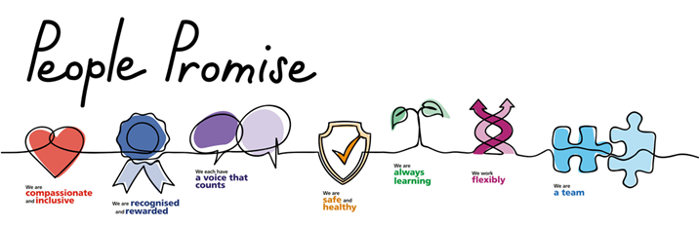

This action plan is for: | Moorfields Eye Hospital – Trust wide action plan
Theme | Action | Lead | Deadline | Intended outcome(s)
We are Safe & Healthy | Continue to roll out Active Bystander | OD Team | October 2023 | Colleagues understand what it means to be an active bystander and have a framework for calling out inappropriate behaviour if they witness it
 | Develop and deliver Active Bystander Extra | OD team | October 2023 | Colleagues can practice using the framework to call out inappropriate behaviour, further developing their skills and confidence
 | Pilot the organisational stress risk assessment framework with a team or department where burnout scores indicate they are a hotspot | OD team in collaboration with identified leads | September 2023 | Identify stressors, put actions in place to mitigate these and improve stress levels within pilot team.  Determine whether wider roll-out would be beneficial and design implementation plan accordingly.
 | Develop and implement Musculoskeletal (MSK) Pathway to prevent and mitigate impact of MSK absences | OD team | November 2023 | Clear support in place to prevent and/or mitigate the duration and impact of MSK absences, which is one of the leading causes of absence in the trust
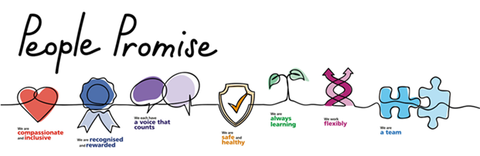

Please provide your feedback, thoughts, and ideas by sending an email to moorfields.od@nhs.net

