Report title | 2021/22 Annual Report and Accounts and Assessment of Going Concern
Report from | Jonathan Wilson (Chief Financial Officer)
Prepared by | Lubna Dharssi (Head of Financial Control)  Jamie O’Callaghan (Head of Corporate Governance)
Link to strategic objectives | We will have a sustainable financial model.

Executive Summary
Annual Report
Paragraph 26 of Schedule 7 to the NHS Act 2006 requires NHS Foundation Trusts to prepare and annual report in a form decided by NHS Improvement. The report has been prepared in accordance with the latest guidance.
Annual Accounts
The accounts have been prepared in accordance with paragraphs 24 and 25 of Schedule 7 to the NHS Act 2006. This paper provides a summary of the main points of the Annual Report and Annual Accounts, including as well as an assessment that preparing the accounts on the Going Concern basis remains appropriate.
The Board is asked to approve the Annual Accounts and Annual Report.
Quality implications
Patient safety has been considered in the allocation of budgets.
Financial implications
Delivery of the financial control total will result in the Trust being able to support its future development.
Risk implications
Potential risks have been considered within the reported financial position and the financial risk register is discussed at the Audit Committee.
Action Required/Recommendation
The Board is asked to approve the Annual Accounts and Annual Report.
For Assurance |  | For decision |  | For discussion |  | To note

2021-22 Review of the Annual Accounts

Summary
This paper is intended to supplement the Annual Report and Annual Accounts to provide commentary to the Board on the major items of note in the 2021/22 Annual Accounts. This covers the primary statements of the accounts and any other material points. A full set of the Annual Accounts are provided in Appendix A.

Statement of Comprehensive Income
This Statement of Comprehensive Income (SOCI) reports the high-level summary of income and expenses for the year, along with interest charges and dividends. In addition, it shows property revaluation impacts that do not flow directly to the bottom-line surplus of the Trust.
A summary of the surplus for the year is shown below:-

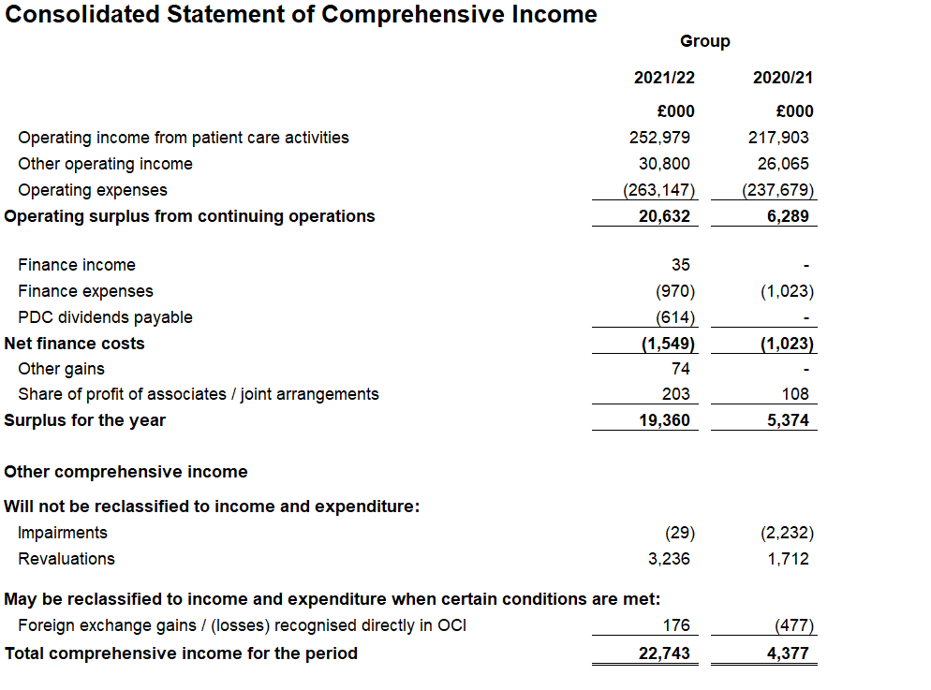

Major points to Note

Area | Full Year | Description
Total comprehensive income for the year | £22.7m | This is the figure shown after the impact of property revaluation gains and losses and certain exchange rates gains and losses, where these items impact the Revaluation Reserve and Other Equity reserve in the Statement of Financial Position, and do not flow directly to the bottom-line surplus. These items show a net gain of £3.3m for the year, which when added to the surplus of £19.4m brings Total Comprehensive Income for the year to £22.7m.
Total income | £284.0m | Total income has increased by £40.0m to £284.0m in 2021/22 from £244.0m in 2020/21. This is largely due to receiving block funding income based on historical activity levels, whilst undertaking reduced activity during the pandemic. There was also increased commercial income during the year.
Total expenses before impairment | £263.0m | Total expenses before impairment have increased by £26.3m to £263m in 2021/22, from £236.7m in 2020/21. Pay costs increased by £10.8m and non-pay costs by £15.5m.
Interest payable and Public Dividend Capital dividends | £1.5m | Interest payable is £1.5m for the year, an increase of £0.5m from last year. Public Dividend Capital (PDC) payments resumed due to increases in the average of the adjusted opening and closing assets employed that are used to calculate the PDC dividend payment.

Statement of Financial Position
The Statement of Financial Position (SOFP) reports a snapshot of the Trust’s assets and liabilities at the 31st March 2022.

Area | Full Year | Description
Non-Current Assets | £111.6m | Intangible assets: increased by £0.3m to £4.2m reflecting capital expenditure in IT infrastructure offset by depreciation.  Property plant and equipment: increased by £9.1m to £106.0m due to capital expenditure partially offset by depreciation and revaluation. Major movements are:  - New additions of +£13.3m  - Depreciation of -£7.4m  - Net revaluation gain to the Revaluation Reserve of £3.2m
Current Assets | £97.5m | Trade and other receivables increased by £4.2m in 2021/22, due to increases around R&D income that were outstanding at the year end. Provisioning against debt remains prudent, but reduced from the prior year due to lower levels of aged debt.  Cash and Cash Equivalents were £69.3m at the end of the financial year, an increase of £0.9m compared to 2021/22.
Current Liabilities | £55.2m | Current trade and other payables reduced by £4.3m, with a £0.3m increase in provisions, and a £3m reduction in deferred income.
Non-Current Liabilities | £33.8m | Borrowings due after more than one year are £31.1m, reducing in line with agreed payment terms.  Provisions for liabilities have reduced by £0.3m to £2.7m.
Taxpayers Equity | £120.0m | Public Dividend Capital: increased by £0.6m to £30.3m due to additional PDC funding in relation to capital.  Revaluation Reserve: increased by £3.2m to £11.0m reflecting revaluation gains in year.  Other Reserves: increased by £0.2m to £0.9m reflecting changes in exchange rate on translation of MEH UAE from AED to GBP.  Income and Expenditure Reserve: increased to £77.8m, reflecting the flow through of surplus for the year.

Assessment of Going Concern

- Introduction
International Financial Reporting Standards (IFRS) require the Trust’s Directors to assess and satisfy themselves that it is appropriate to prepare financial statements on a going concern basis.
Where management are aware of material uncertainties in respect of events or conditions that cast significant doubt upon the going concern ability of the trust, these should be disclosed.
The Department of Health Group Accounting Manual provides the following interpretation of the going concern requirements set out in IAS1:
“The anticipated continuation of the provision of a service in the future, as evidenced by inclusion of financial provision for that service in published documents is normally sufficient evidence of going concern”.
The Foundation Trust Annual Reporting Manual (FTARM) further states that there is no presumption of going concern status for NHS foundation trusts. Directors must decide each year whether or not it is appropriate for the NHS foundation trust to prepare its accounts on the going concern basis.
Guidance was issued at the end of 2020/21 by NHSE/I attached (Appendix B), and updates within the FTARM which sets out how trusts should assess going concern and associated uncertainties for this, and future year ends. This updated approach has been agreed with the audit firms.
The FTARM states the following:
An NHS foundation trust’s assessment of whether the going concern basis is appropriate for its accounts should therefore only be based on whether it is anticipated that the services it provides will continue to be provided with the same assets in the public sector. This is expected to be the case for NHS foundation trusts unless exceptional circumstances indicate otherwise; these should be discussed with NHS England and NHS Improvement. Where the continued provision of services in the public sector is anticipated to apply, there will not be any material uncertainties over going concern requiring disclosure.
This means that, for the 2020/21, 2021/22 and onwards, while management in NHS bodies will still need to document their basis for adopting the going concern basis, this assessment should solely be based on the anticipated future provision of services in the public sector. This means that it is highly unlikely that NHS organisations would have any material uncertainties over going concern to disclose.

- Access to Funding / Liquidity

Whilst no longer required under the FTARM the Trust has considered it has adequate resources to continue in operational existence for the foreseeable future.

The Trust’s banking is conducted primarily through the Government Banking Service (GBS). A weekly cash flow forecast is used to aid cash management; and cash forecasts for the full financial year are reported to the Trust Board on a monthly basis. The Trust’s cash position during 2021/22 has been consistently above plan and stood at £71.9 million at the end of April 2022 – equating to liquidity days of 99.

The 2022/23 plan forecasts a healthy cash balance with reserves being used to fund carry forward capital and the Oriel redevelopment. The current plan gives closing cash balance of £57.1m with no requirements for external funding (other than Oriel and other externally funded capital). This is a draft assessment which will be updated with more information as it becomes available, and a detailed cash flow forecast for the next 12 months is shown in Appendix C.

- Recommendation
The Trust Board is required to consider if the following statement applies:
The going concern basis is appropriate for the trust’s accounts and this assessment is based on the services it provides continuing to be provided with the same assets in the public sector.
The following statement will be included in the Annual Report and Accounts:
“After making enquiries, the directors have a reasonable expectation that the services provided by the NHS foundation trust will continue to be provided by the public sector for the foreseeable future. For this reason, the directors have adopted the going concern basis in preparing the accounts, following the definition of going concern in the public sector adopted by HM Treasury’s Financial Reporting Manual.”

